Document A

Work for You at Your Distilling House

Original transcription
Ship captain and merchant Richard Derby owned a rum distillery in Salem. At rum distilleries, molasses was used to create rum, a profitable trade commodity in New England. Samuel Fisk, another Salem colonist, enslaved a man who worked at Derby’s distillery in 1762 and 1763. Fisk may have “rented out” the man he enslaved. He wrote this invoice for money owed to him by Derby for one year of the enslaved man’s labor.

Salem June 23 1763

Capt Richard Derby To Sam” Fisk

To my Negro man’s work for you at your Distilling house from
March 18 1762 To march 10 1763
s
To his work in march 19 Days a 3/ . . . . £ 1..16
April 25 Days “D” . . . . . . 3..15
May 24 “D” . . . . . . 3..12
June 24 “D” . . . . . . 3..12
July 23 “D” . . . . . . 3..9
August 26 “D” . . . . . . 3..18
September 25 “D” . . . . . . 3..15
October 25 “D” . . . . . . 3..15
November 26 “D” . . . . . . 3..18
December 27 “D” . . . . . . 4..1
January 1763 26 “D” . . . . . 3..18
February 23 “D” . . . . . . 3..9
March 9 “D” . . . . . . 1..7
295 Law” money 44..5

Errors Excepted Sam” Fisk

Document A

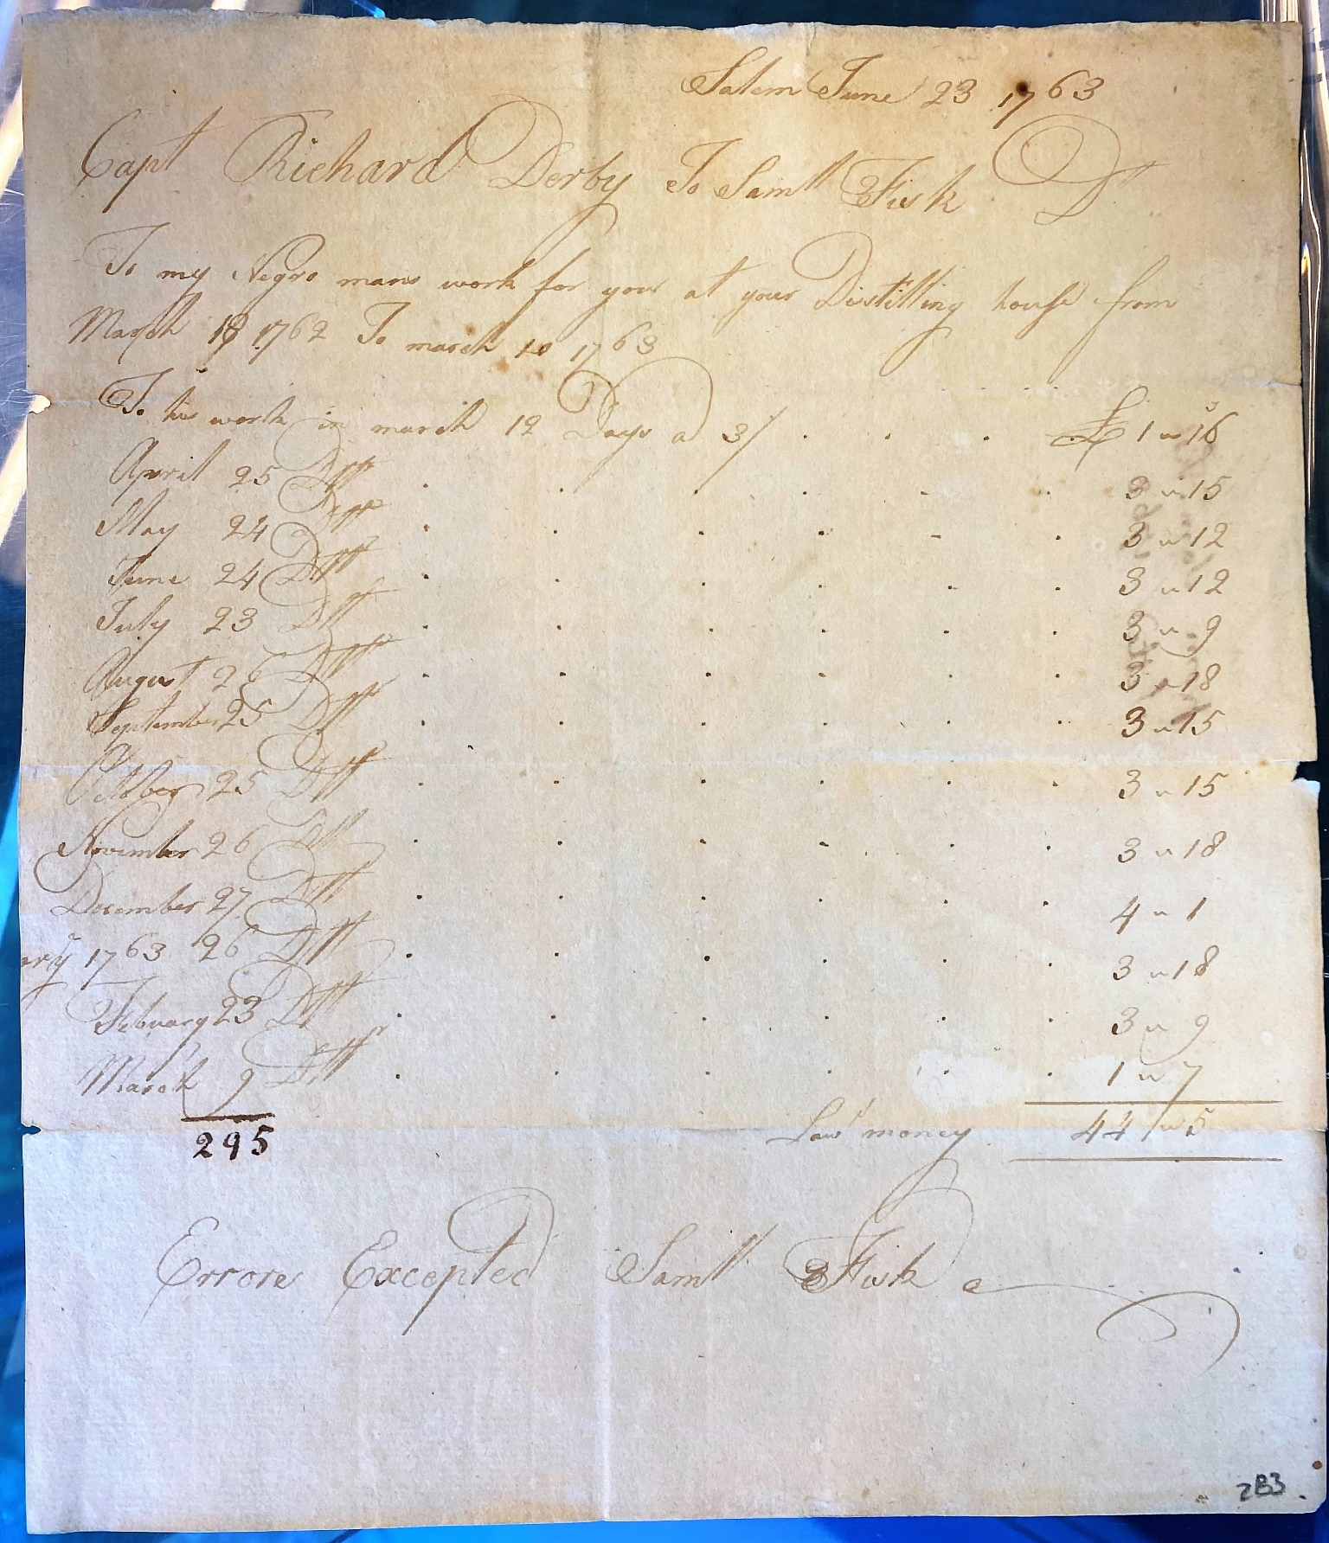

Source
Derby Family Papers, MSS 37, Box 14, Folder 9
Courtesy of The Phillips Library, Peabody Essex Museum, Salem, Mass

Document B

Marriage of Jane and Isaac
Original Transcription
Jane was a Salem woman enslaved by Captain Richard Derby. She married Isaac, a man enslaved by Samuel Gardner, in 1754. Their marriage is recorded in the free, online database, “Early Vital Records of Massachusetts.” The database holds information collected from church records, town records, private records, gravestone inscriptions, and newspaper articles from across Massachusetts.
This page documents the marriages of free and enslaved Black people (in Salem) whose names started with the letter “J.” The records span from 1747 – 1845. Jane and Isaac are both identified as “servants.” This word was a euphemism (or substitute) to describe African people who were enslaved.

SALEM MARRIAGES
…
…
…
Jane, servant of Capt. Richard Derby, and Issac, servant of Sam[uel]l Gardner, Jan. 23, 1754.*
Jane [servant of George Small of Danvers. int.], and Primus [servant of Hon. B. Lynde, Esq. int.], at Danvers, Dec. 30, 1757.*
Jane [servant of Daniel Mackey. int.], and Jack [lately a servant of Nathaniel Archer, dec. int.], certify. Feb. 5, 1775.*
Jane, belonging to wid. Lois Lee, and Cesar Harvey, belonging to Jos. Dowse, int. Oct. 17, 1778.
Janes, Flora, and Charles Hower, int. March 11, 1815.
Jenny, servant of Richard Ward, and Milo, servant of William Pool, of Danvers, deceased, int. April 20, 1776.
Jarret, Ketiah [Kesiah. int.], and Peter J[ames. int.] Williams, July 16, 1826.*
Jethro, servant of William Hunt, and Phebe, servant of Rich-ard Elvins of Dunston, May 18, 1747.*
Joe [servant of John Sweetser. int.] and Dinah [servant of Jonathan Ropes, jr. int.], certify. July 4, 1776.*
Johnson, Ab[raha]m, and Catherine Hawkins, Aug. 31, 1835.
*Intention also recorded.

Document B

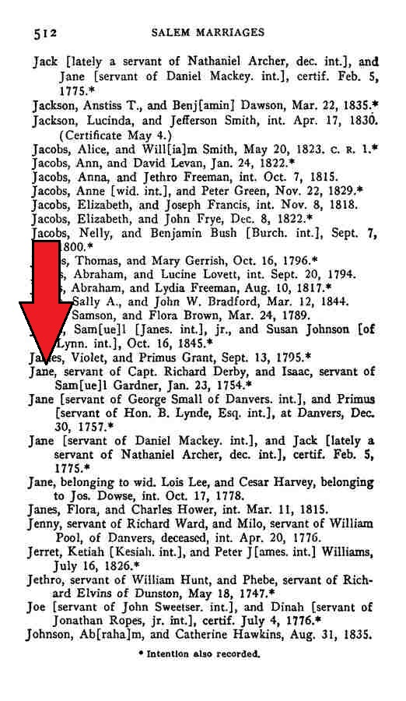

Image Source
Early Vital Records of Massachusetts, From 1600 to 1850. www.ma-vitalrecords.org

Supplemental Primary Source Documents

Document C

Understands Farming, Shoemaking, and Fishing
Original Transcription
This “for sale” advertisement was printed in the Salem newspaper, “The Essex Gazette,” on November 20, 1770. The ad describes the labor of a 22-year-old man and a 27-year-old woman, both enslaved by Thomas Herrick of Beverly (next to Salem). Samuel Hall owned “The Essex Gazette” and was paid by Herrick to print this ad. Advertisements for “runaway” and “for sale” enslaved people were common and an important source of revenue for newspaper printers.

To be SOLD,
A stout, healthy Negro Man
of 22 Years of Age, who understands
Farming and Shoemaking, also the Fishing
Business, which last he has followed these
five Years past, and catches a good Share.
---- Also, a Negro Woman of 27 Years
of Age, who understands any Household Work.
Any Persons that incline to purchase, for
further particulars enquire of THOMAS
HERRICK at Beverly.

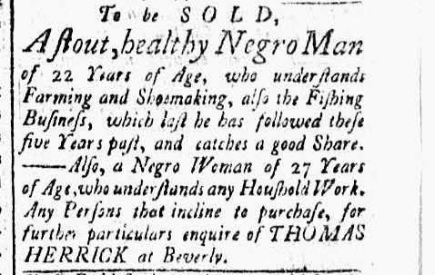

Document C
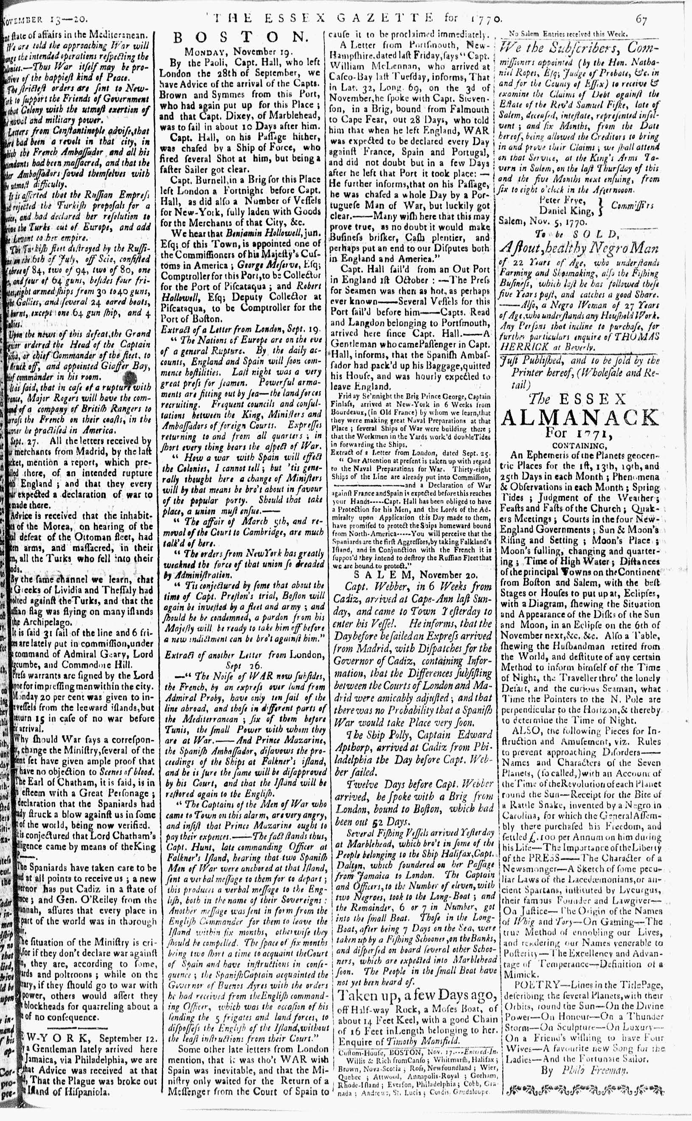

Image Source
“The Essex Gazette.” November 20, 1770. Courtesy of Readex: America’s Historical Newspapers. Early American Newspapers, Series 1: From Colonies to Nation.

Document D

To the Selectman of the Town of Salem
Original Transcription
In the 18th and 19th centuries, enslaved and free Black people across New England participated in annual celebrations known as “Negro Election Day.” Some white people supported the holiday, while others did not. Nine Salem residents signed this petition in 1768, calling on the town government to “regulate” the celebration in Salem. Among them was Hasket Derby, son of Captain Richard Derby.

To the Selectmen of the Town of Salem _______
The Petition of the Subscribers Inhabitants of said
Town humbly sheweth that as great Disorder
usually happens among us on Election Days, by
Negroes assembling together, beating Drums and
Making use of powder with firing of Guns etc. etc.
^ X Some have ??? appeared on such Days with
Swords and all which we think of bad Tendency
we therefore pray that ???? in your Warrant
for next Town meeting be ??? to know if the
Town will obtain a Bylaw to regulate those matters
or consider of some other Method to prevent for
the future of the Appearances of such Disorder ----
in the Town and your petitioners ?? ?? ???
shall ever pray ?? ---
Salem may 5 1768

Peter Frye

Sam Barton Jr
Jo Grant
G Crowninshield
Hasket Derby
Jon a Andrews
ThS Musson
John Prince
Ebenezer Bickford

Document D
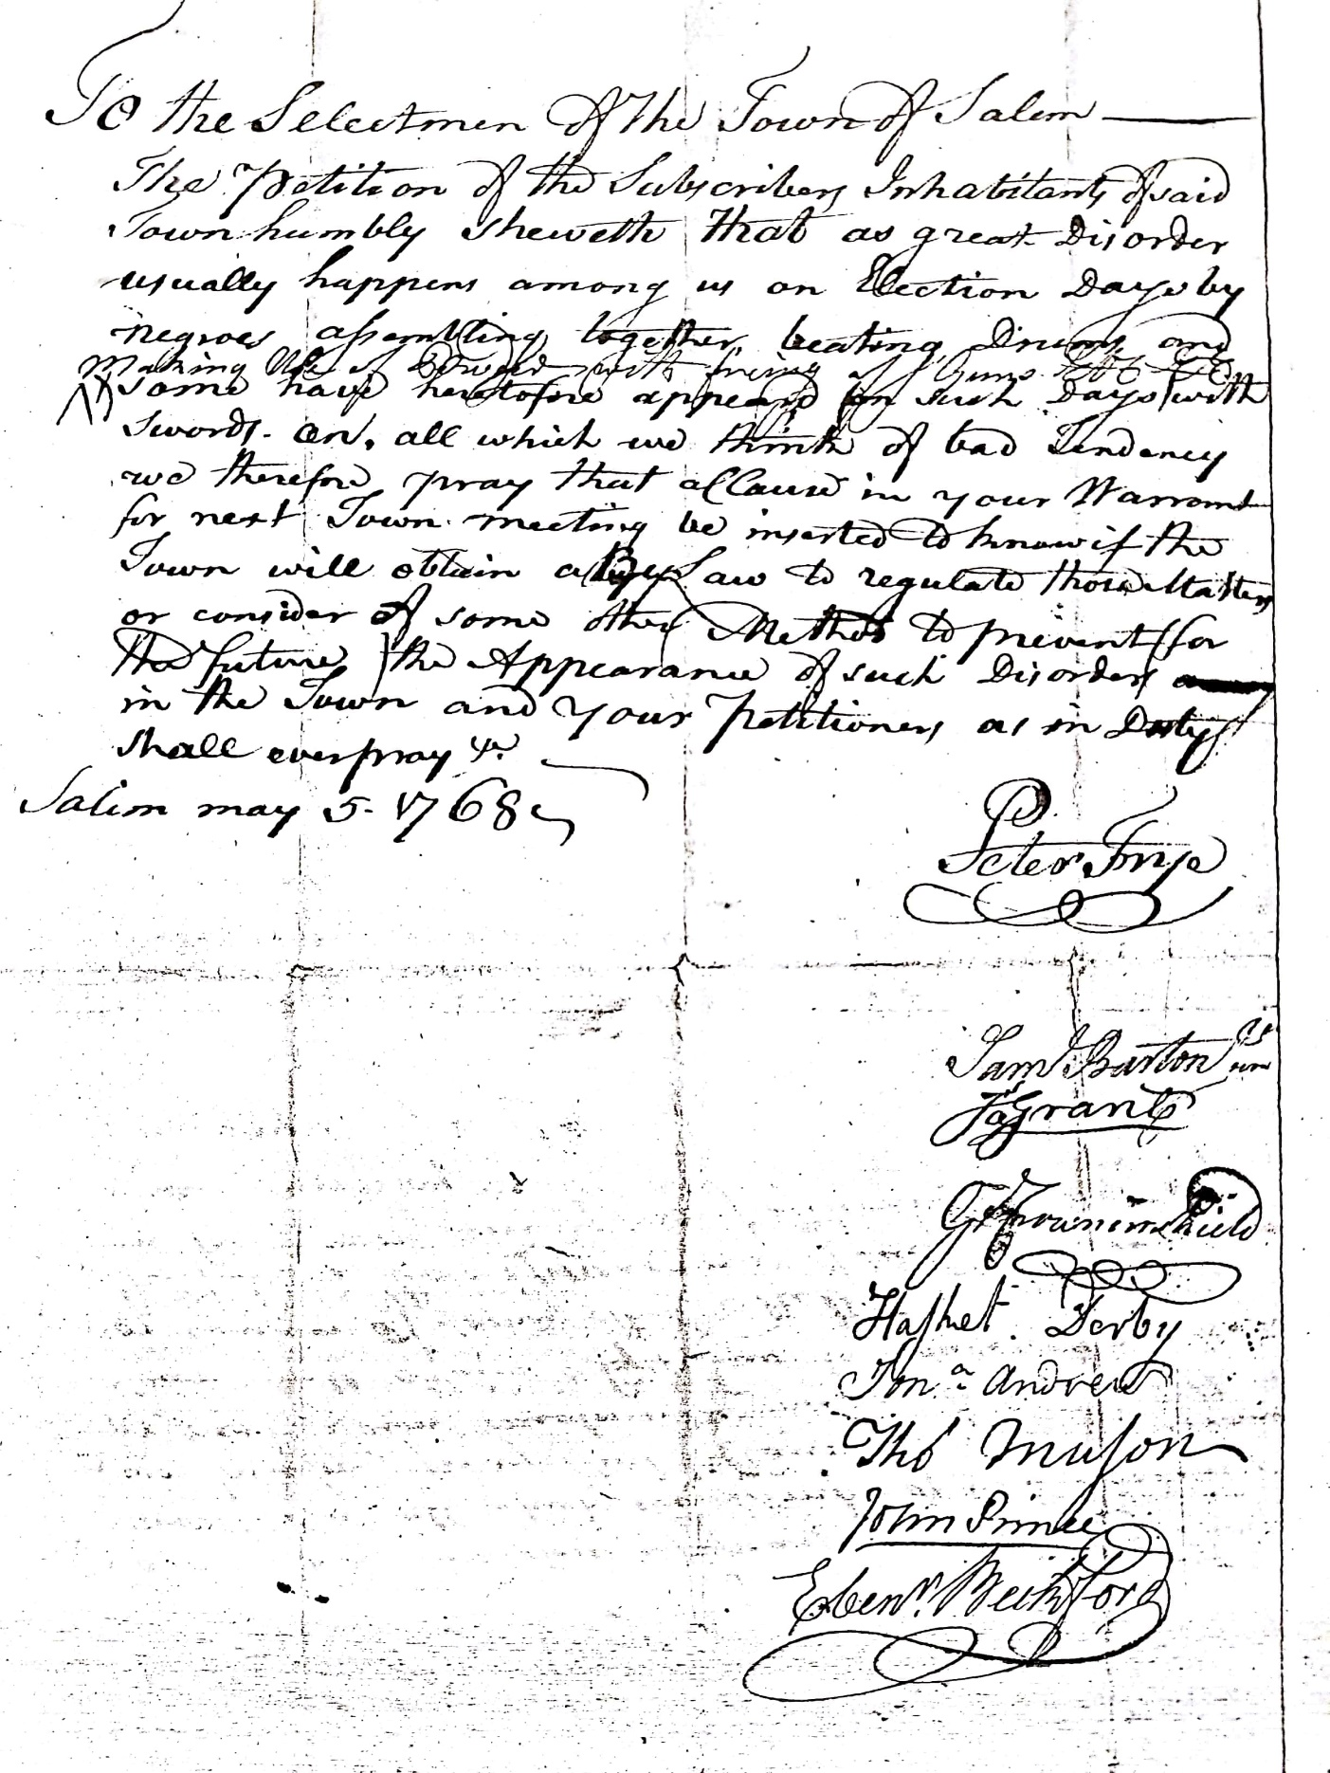

Image Source
Petition, Peter Frye, “Negroes Create Great Disorder” on Election Day, May 5, 1768. Courtesy of Salem State University Archives and Special Collections, City of Salem Archives Collection.

Document E

To Be Sold, A Likely Negro Girl, Twelve Years
Original Transcription
This “for sale” advertisement by an unknown colonist appeared in the “The Essex Gazette” July 7, 1772. Colonists interested in purchasing this enslaved child would seek information from the newspaper owner and printer, Samuel Hall of Salem. The advertisement was printed just below a “runaway” advertisement for an enslaved man named Cato (see full image on next page).

TO BE SOLD,
A Likely NEGRO GIRL, twelve Years
and a half old, healthy and strong, able to do all sorts of
Household Work, particularly about Cookery; can sew well on
plain Work, and has been taught to read. Enquire of the Printers.

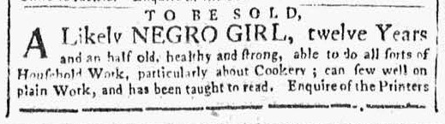

Image Source
The Essex Gazette, July 7, 1772. Vol. IV, No. 206.

Document E
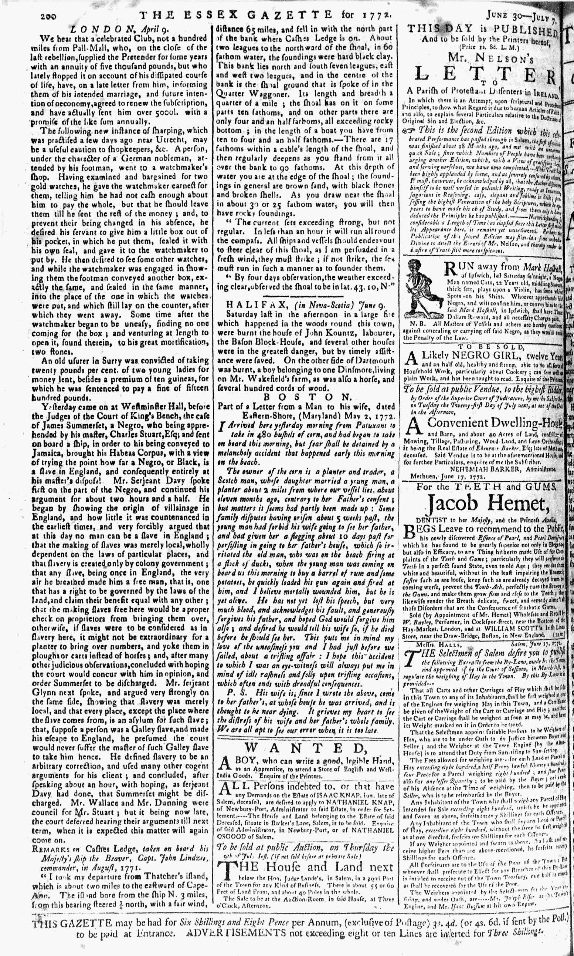

Image Source
The Essex Gazette, July 7, 1772. Vol. IV, No. 206. Courtesy of Readex: America’s Historical Newspapers. Early American Newspapers, Series 1: From Colonies to Nation.

